For Immediate Release: July 13, 2021

TAYLOE PIGGOTT GALLERY ANNOUNCES PAWS/PAUSE
A SURVEY EXHIBITION OF WORK BY ARTIST JANE ROSEN

Exhibition Dates: 5 August – 26 September 2021

JACKSON, WYOMING - TAYLOE PIGGOTT GALLERY is pleased to present Paws/Pause, a survey exhibition of sculpture and drawings by artist Jane Rosen, on view from August 5th through September 26^{h}. Rosen describes the exhibition as a series of vignettes gleaned from the arc of her life, which has, in a sense, been defined by the dogs by her side. Beginning with Tartuffe, a stray rescued from the train station while studying at Cornell, Rosen’s story relies upon supporting characters with tails. The title piece, Paws | Pause, presents a series of elongated stone, marble inlay and glasswork paws that hang, punctuated at intervals, and casually arranged in tribute to late artist Susan Rothenberg upon the wall. Without words, Rosen pays tribute to each of the animals who have guided her and sat by her side through the years. Each of these sculptural paws allots a pensive pause in time.

There’s an unconscious melding of her world with her art. The two are justly inseparable: Jane Rosen is always working. Within walking distance from her home, her naturally lit studio is home to a veritable menagerie of animal forms. An enormous marble raven commiserates with handblown glass bucks perched along the wall; a 7-ft. limestone Barred Owl looks out to his neighbor, Egyptian Man in Horus. It’s as though these beings compel the artist to bring them forth, whether in stone, or handblown glass, or in intimate, painted mixed media works on paper she playfully calls her “drawings.” Truly, Jane Rosen encapsulates the image of an artist in the prime of her career. And through her work, Rosen is the ultimate storyteller.

A few years ago, in a conversation with Richard Whittaker, Jane Rosen spoke about art in a way that gets to the heart of Paws | Pause: “I would say art is the language of the body and feeling trying to make a relationship between the disconnected part of my mind that is desperately trying to understand. That, as a possibility, is what art does. It’s informing and transforming another part of myself and showing me what’s really going on.” That is also, it so happens, what dogs do.

Jane Rosen is a born and bred New Yorker, despite having settled on her farm in rural California over 30 years ago. Rosen’s childhood in the city involved regular visits to the Egyptian collection of hawks and falcons at the Met. Having graduated from NYU, Rosen also studied at the Art Students League, and held a senior faculty position at the New York School of Visual Arts. She studied under well-known names like Sol LeWitt, Chuck Close and Esteban Vicente, and herself enjoyed an active career as an arts educator at prestigious institutions, including Stanford University and over 10 years at UCal Berkeley. She was revered among her students, many of whom have taken her signature drawing lessons into their own teaching practices. Rosen was selected by the American Academy of Arts and Letters for inclusion in their 2010 Annual Invitational in New York, a prestigious exhibition juried by some of the greatest artists of our time. Rosen’s work has been reviewed in the New York Times, ArtForum, Art in America, and Art News. Her work has been exhibited extensively. It is in numerous public and private collections including the Albright-Knox Art Gallery, the Aspen Art Museum, the Brooklyn Museum, the Chevron Corporation, the collection of Grace Borgenicht, JP Morgan Chase Bank, the Luso American Foundation, the Mallin Collection, the Mitsubishi Corporation, and the Museum of Contemporary Art San Diego.

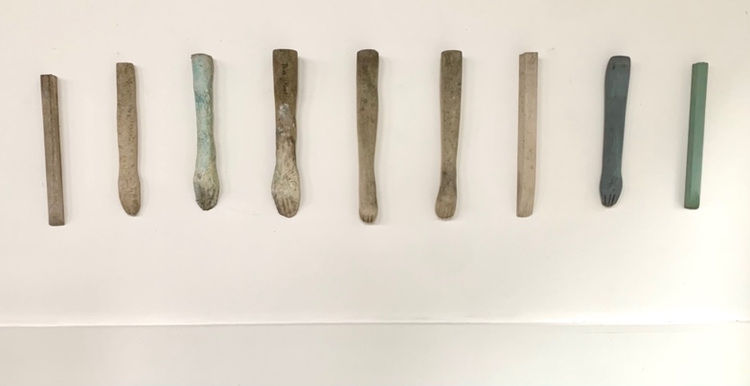
Jane Rosen
Paws/Pause, 2021
Handblown pigmented glass, limestone
24 x 97 x 3 inches
(9 paws installed)

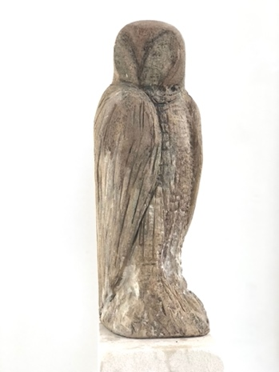
Jane Rosen
Barred Owl, 2020-2021
Limestone
78 x 8 x 15 inches

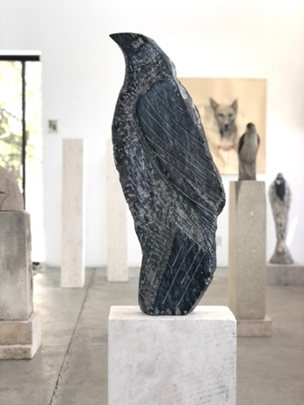
Jane Rosen
Black Marble Raven, 1989-2021
Black marble and limestone
59 x 16 x 8 inches

TAYLOE PIGGOTT GALLERY
Specializing in modern and contemporary art, Tayloe Piggott Gallery expresses a sharp appreciation for exceptional aesthetic vision. Based in Jackson, Wyoming, the gallery showcases sophisticated, unique artworks in a modern setting. Always interested in artistic discovery, the gallery expanded to create The Project Space: a collaborative place for the local and global community to share ideas, showcase work, host events, and expand artistic concepts. Mindful and thought-provoking, Tayloe Piggott Gallery aims to enrich cultural dialogue by bringing remarkable artists into an already flourishing arts community.
From first time buyers to seasoned collectors, our gallery assists a wide range of clients with the intricacies of collecting contemporary art. Our staff has the knowledge and expertise to facilitate art acquisitions, advise collection management, and curate the interiors of private spaces.
Media contact: Katie Franklin, katie@tayloepiggottgallery.com

